Chapter 16, Problem 25.

Calculate v(t) for t > 0 in the circuit of Fig. 16.48.

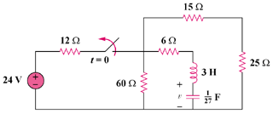

Figure 16.48
For Prob. 16.25.

